**DAILY ONLINE ACTIVITIES SUMMARY**

|  |  |  |  |  |  |  |  |  |
| --- | --- | --- | --- | --- | --- | --- | --- | --- |
| **Date:** | 03-06-2020 | | | | | **Name:** | SINDHU N | |
| **Sem & Sec** | 6th and B | | | | | **USN:** | 4AL17CS094 | |
| **Online Test Summary** | | | | | | | | |
| **Subject** | | PAP (ASSIGNMENT 1) | | | | | | |
| **Max. Marks** | | 20 | | **Score** | | | 15 | |
| **Certification Course Summary** | | | | | | | | |
| **Course** | PYTHON FOR MACHINE LEARNING | | | | | | | |
| **Certificate Provider** | | | Greatlearning academy | | **Duration** | | | 1 WEEK |
| **Coding Challenges** | | | | | | | | |
| **Problem Statement:** GIVEN 3 PROBLEMS | | | | | | | | |
| **Status:** Completed | | | | | | | | |
| **Uploaded the report in Github** | | | | | Yes | | | |
| **If yes Repository name** | | | | | https://github.com/lsindhungowda/Daily-report | | | |
| **Uploaded the report in slack** | | | | | Sindhu N  Yes, I uploaded the report in slack | | | |

**SNAPSHOT OF ASSIGNMENT MARKS:**

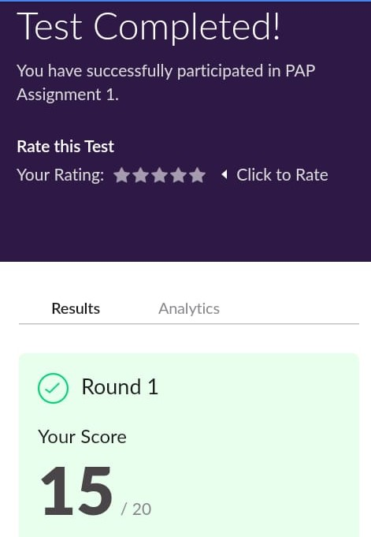

**SNAPSHOT OF ONLINE CERTIFICATION COURSE:**

**SCREENSHOT1:** 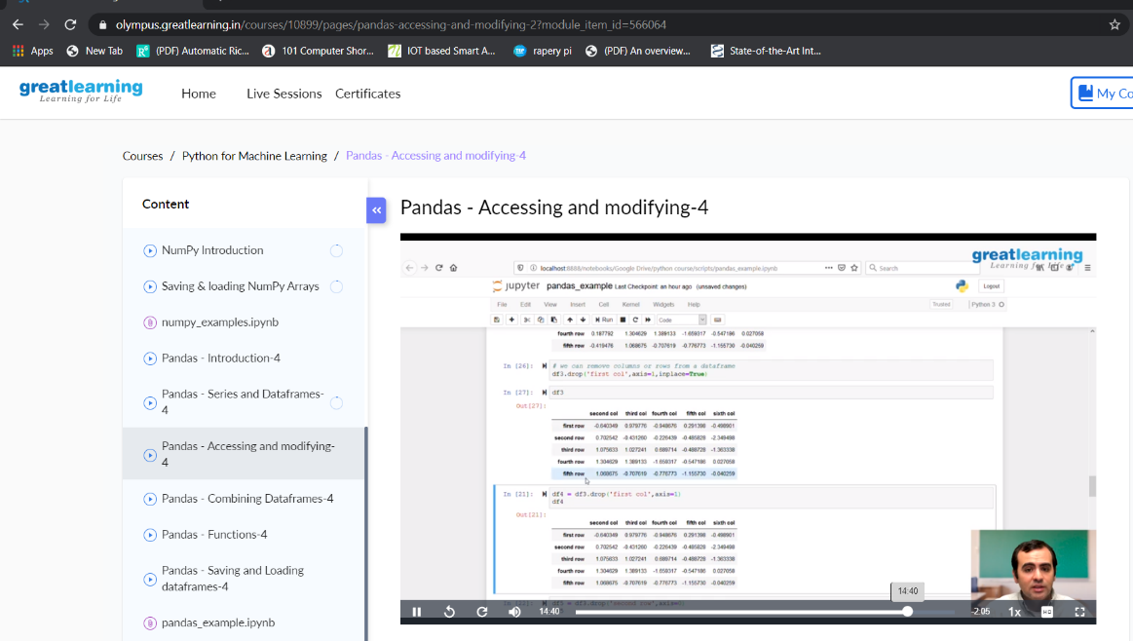

**SCREENSHOT2:** 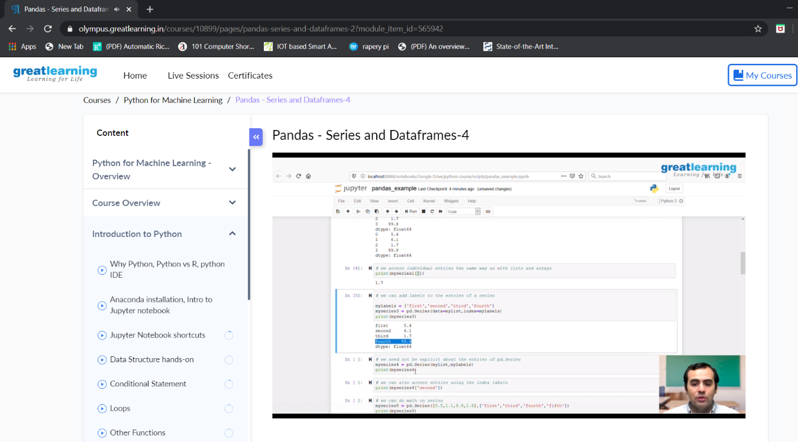

**SNAPSHOT OF ONLINE CODING:**

**PYTHON PROGRAM 1:**

Python Program to find the largest number in a list without using sorting algorithm.

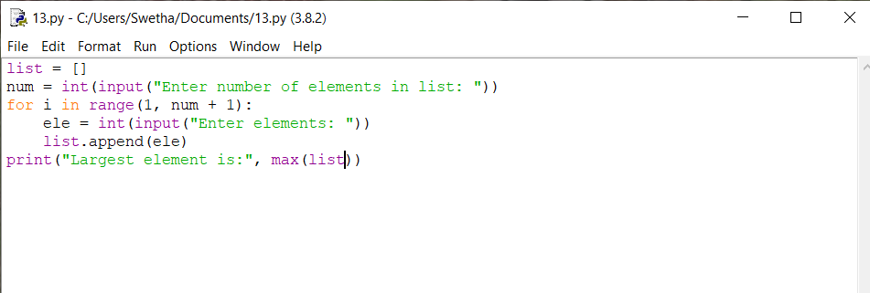

**OUTPUT:**

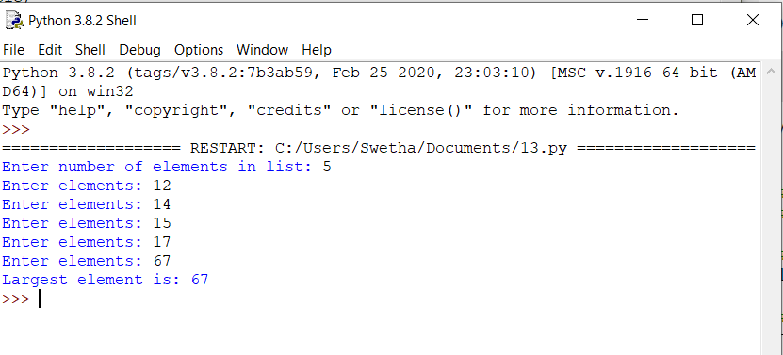

**PROGRAM 2:**

Take a list of length 3 containing integers, find out which is larger, first or last one and set all the elements in the list to be that value. Print the updated list.

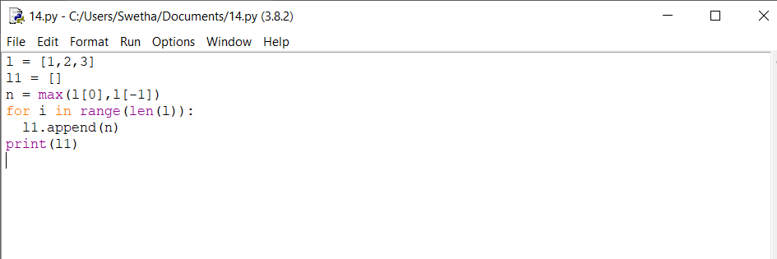

**OUTPUT:**

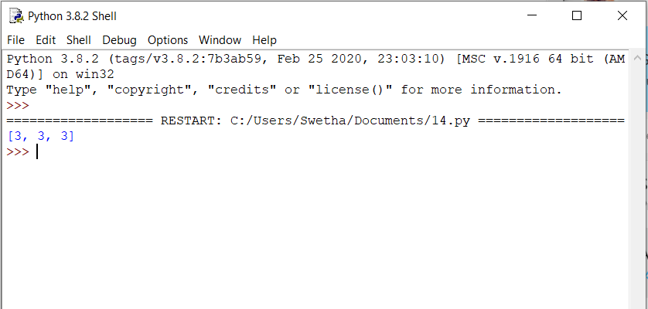

**PYTHON PROGRAM 3:**

Python Program to print prime numbers in the given range.

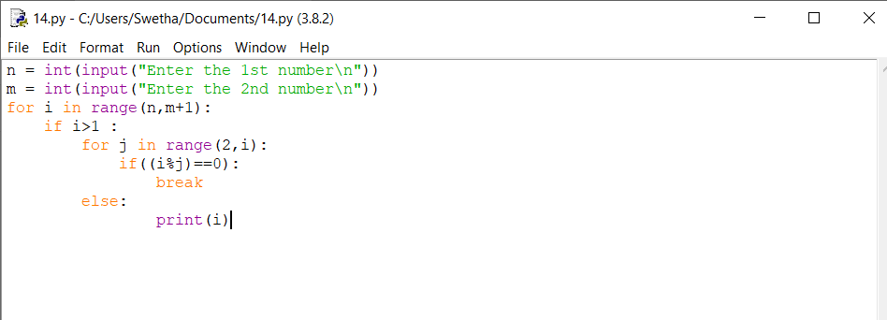

**OUTPUT:**

